Report
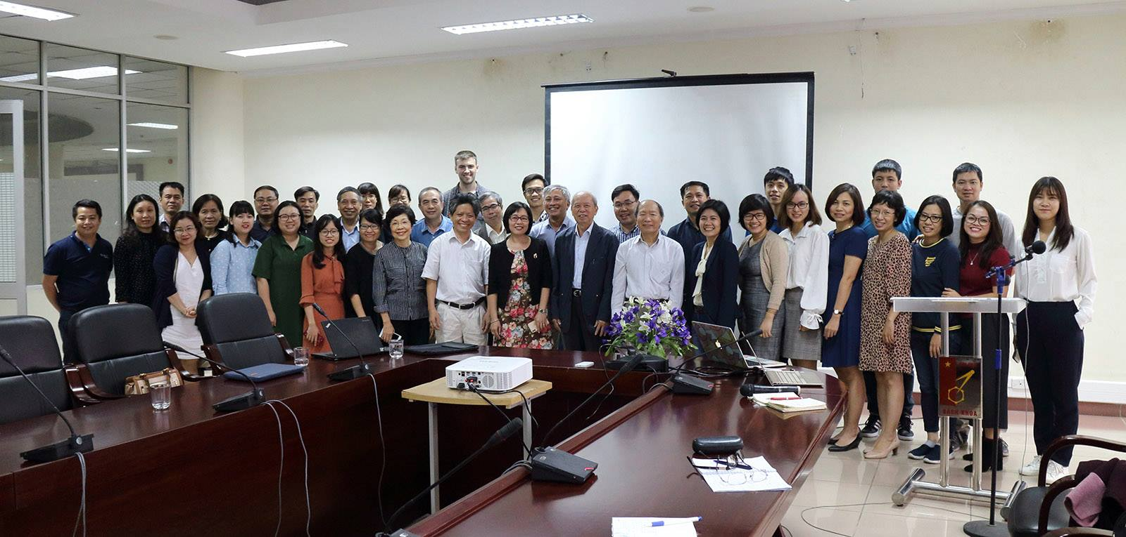
Low-cost Air Sensors in Air Quality Monitoring and Management in Vietnam Opportunities and Challenges

Contents
I. Overview 1
1. Background 1
2. Objective 1
3. Tentative agenda 2
4. Participants 3
II. Presentations 3
1. Vietnam Clean Air Partnership (VCAP) – Overview of Air Quality Monitoring Systems and Platforms Using Low-cost Air Sensors: Applications and Limitations 3
2. Centre for Environmental Monitoring (CEM), Vietnam Environment Administration –Overview of Automatic Air Monitoring System in Vietnam 5
3. Center of Multidisciplinary Integrated Technologies for Field Monitoring (FIMO) – Air Monitoring System FAirNet Using Low-cost Air Sensors 5
4. School of Environmental Science and Technology (INEST) – Study on Characteristics of PM_{2.5} in Hanoi with Panasonic Sensor 7
5. Live&Learn and SPARC Lab, School of Electronics and Telecommunications (HUST): Adaptation of Low-cost Air Sensors in Regular Scientific: Activities at Schools in Hanoi 8
6. D&L: IoT Ecosystem 8
III. Panel Discussion 9
1. Questions and Answers 9
2. Recommendations 10
Annex (Photos) 12

I. Overview

1. Background
Air pollution worldwide continues to invade the air that we breathe, and has become a serious health threat, especially to those who already suffer from heart and lung diseases, such as COPD and asthma. The percentage of the population which lives in polluted urban areas that exceed the WHO's recommended limit of air quality is shockingly over 80%.
In the last ten years, miniaturization and other technological advances have brought about a number of low-cost sensors (< $2500) that are designed to measure atmospheric particles and gases. The emergence of low-cost, user-friendly and compact air pollution platforms enables observation at high spatial resolution in near-real-time, and provides new opportunities to simultaneously enhance existing monitoring systems, as well as engages citizens in active environmental monitoring. That also provides a whole set of capabilities in the assessment of human exposure to air pollution.
In Vietnam, low-cost air sensors have been introduced by domestic research institutes and the private sector. The sensor devices can be used in conjunction with the official regulatory monitoring stations to broaden the access to ambient air quality information, especially at local scale. However, the development of air sensor technology is accelerated globally and locally with great concerns on quality of the data. This workshop hence provides the knowledge and an open discussion on the current perspectives, and evaluation and application of the air sensor technology in strengthening air quality monitoring work in Vietnam.

2. Objective
The overall objective of this workshop is to advance the collective knowledge of the use of low-cost air sensors in Vietnam by reviewing the current performance of low-cost air sensors and their drawbacks, as well as their technical implication for users and regulators/technical supervisor. In light of that, the workshop opens a platform for discussion with the following topics included: (1) best practices for deployment and calibration of low-cost air sensor systems, (2) data standardization efforts and database design, (3) advances in sensor calibration, data management, and data analysis and visualization, and (4) lessons learned from research/community partnerships to encourage purposeful use of sensors and create change/action. Expectedly, the workshop aims at exploring the full potential of low-cost air sensors especially in Vietnam’s context. The workshop also discusses the unresolved issues, and technological limitations that still remain within the low-cost air sensor arena, and provides recommendations for users and regulatory agencies.

3. Workshop agenda
Time | Content | In charge
13.00 – 13.30 | Registration | Live & Learn
13.30 – 13.40 | Opening speech | VCAP  INEST
13.45 – 14.00 | Overview of air quality monitoring systems and platforms using low-cost air sensors: applications, limitations and applications worldwide. | VCAP
14.00 – 14.20 | Air quality monitoring and management in practice in Vietnam/Hanoi | CEM – MONRE
14.20 – 14.40 | Information on and awareness of air quality in Vietnam: Are low-cost air sensor platforms a solution? | FIMO
14.40 – 15.00 | Low-cost air sensors in air quality research | INEST
15.00 – 15.20 | The use of low-cost air sensors in citizen science: activities at schools in Hanoi | Live & Learn  HUST
15.40-16.00 | Introduce the solution "PAM AIR": Indoor/outdoor sensors and platforms | D&L
16.00 – 16.10 | Question and Answer | Plenary
17.10 – 17.20 | Discussion topics:  - Best Practices for Deployment and Calibration of Low-Cost Air Sensor Systems  - Advances in Sensor Calibration, Data Management, and Data Analysis and Visualization  - Data Quality Management  - Community Engagement: Leveraging Low-Cost Air Sensors and Opportunities for Community-Driven Science
17.20 – 17.30 | Conclusion | VCAP  INEST  Live & Learn

4. Participants
The workshop gathers practitioners whose work relates to low-cost air sensors that are used to monitor air quality. The community of practices hence includes individuals from academia, industry, non-profit groups, development partners, community-based organizations, and regulatory agencies.

II. Presentations

1. Vietnam Clean Air Partnership (VCAP) – Overview of Air Quality Monitoring Systems and Platforms Using Low-cost Air Sensors: Applications and Limitations
The development of low cost air sensors is motivated by the society’s increasing demand for improving living quality, health conditions, and surrounding environment. The air quality of indoor and outdoor settings changes upon time and space, depending on pollution sources and weather, and is determined by the level of PM2.5, SO₂, NO_{x}, O₃, CO₂, etc. The methods to determine air quality include: (1) air monitoring stations managed by government agencies which are considered as the official sources to quote for results. However they are often high – invested (USD 300.000 plus), time and high – skilled - consuming with high cost for maintenance; and (2) low-cost air sensors developed by private companies and research institutions, which are more affordable (up to USD 2000), but until now have been only used as a reference and for educational purposes and not yet used by the government for air quality monitoring and management. Air quality data collected is processed through systems such as Big Data, AI, and Blockchain.
The following table compares air monitoring stations, which provide data for air quality management, with current low-cost air sensors introduced to the markets based on selected criteria:
Criteria | Air Monitoring Stations | Low-cost Air Sensors
Purpose | Provide accurate data for air quality management | For reference, education, science, awareness
Methodology | Standardized | Unstandardized
Data accuracy | High | Unidentified
Price | High | Low
Operation fee | High | Low
Operation | Complex, requires training for monitoring staff | Simple, can be used by anyone
Technical staff | Required | None
Technology | Complex | Simple
Life cycle | Long | Short
Mobility | Fixed | Portable
Installation | Complex | None
Size | Large | Small and Lightweight
Spatial coverage for online metrics | Limited | Wide-ranged
Table 1. Comparison between Air Monitoring Stations and Low-cost Air Sensors by VCAP
In conclusion, low-cost air sensors’ strengths include low price, large numbers of sensors, friendly interface, and flexibility, while their weakness is low data accuracy. Domestic companies enjoys favorable conditions (1) various technologies and devices introduced to the market, increasingly developed integrating, processing, and connecting tools; (2) human resources for software development in Vietnam; and (3) increasing demand from users. However, a number of challenges will need to be overcome to promote the development of low-cost air sensors, namely (1) technical aspects (calibration method and component parts); (2) data sharing, weather and terrain information; (3) experience and resources sharing; and (4) competition and copyright. In order to overcome these challenges, private companies and research institutions need to coordinate to share knowledge and experience, and develop a model for a platform and software for air quality data management.

2. Centre for Environmental Monitoring (CEM), Vietnam Environment Administration – Overview of Automatic Air Monitoring System in Vietnam
CEM introduced in general their existing automatic monitoring system and explained comprehensively on how they monitor the air quality by both fixed and mobile air quality monitoring stations). To date, they have had 800 working air monitoring stations in Hanoi and national wide and surveilling parameters such as CO, O_{3,} CO₂, SO₂, NO_{x}, TSP, PM₁₀, PM_{2.5} and PM_{1,} THC, BTEX, etc. By showing the map of automatic air monitoring station networtk, CEM brought out the information of the current situation of air monitoring in Vietnam. The speaker also explained how the data is collected through the stations, transmitted, proceeded and published via websites, annual reports, conferences and information releases. The presentation also provided presentations and comparisons of 3 different types of air monitoring stations including fixed stations, sensor stations and optic stations, their advantages and shortcomings from their experiences. CEM recommended that researchers should be careful when collecting the data from low-cost air sensors as they are not qualified according to the European legislation and international standards methods.

3. Center of Multidisciplinary Integrated Technologies for Field Monitoring (FIMO) – Air Monitoring System FAirNet Using Low-cost Air Sensors
Air pollution in Vietnam is very critical, especially in big cities and urban areas, which significantly impacts communities’ health. In response to that, various monitoring systems have been developed and environmental protection laws have been issued and enforced with technical regulations and air pollution controlling, mitigating and improving programs.
FIMO has also developed FAirNet - an air pollution monitoring system. The system consists of 4 components: (1) FAirKit: Air quality monitoring device using low cost sensor; (2) FAirServer: Information processing and storage system; (3) FAirWeb: Platform to display air quality information on website; and (4) FAirApp: Application to display air quality information on mobile phones.
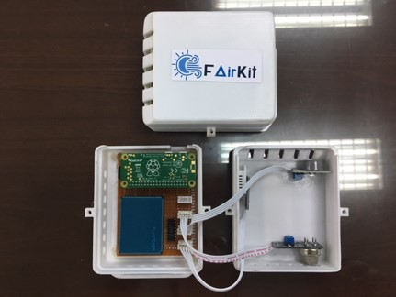
Photo 1. Design of FAirKit
FIMO has calibrated FAirKit using the fixed air monitoring system of Hanoi Environmental Protection Agency as a standard reference before introducing the device to the market. FAirNet, which is a joint system with Taiwan, consists of more than 1000 devices over the world. The system demonstrates the trend of air quality by presenting air quality index in the last 24 hours. FAirNet also allows users to register to receive information through website and mobile app, and provides warning for vulnerable groups to air pollution.
Currently, in cooperation with Hanoi EPA and Live and Learn, FIMO is installing the low-cost air sensor Air Pollution Monitoring Network in Hanoi to collect real – time data of air quality and transmit it to FAIRNet. It can be used to raise public awareness and produce alerts at high concentration through the provision of air monitoring information online. The total number of air sensors will be from 40-45, 17-20 of which will be installed in Hoan Kiem District while the rest will be installed in other hot spots of air pollution in Hanoi, such as craft villages, landfill spots, and cemeteries. Until now, 2 stations have been installed in Hoan Kiem District, Hanoi in cooperation with GIZ, one at Cau Dong Market and the other one at Hanoi Book Street.

4. School of Environmental Science and Technology (INEST) – Study on Characteristics of PM_{2.5} in Hanoi using low – cost Panasonic Sensor
In 2016-2017, the School of Environmental Science and Technology (INEST) conducted the study “Charactering PM_{2.5} in Hanoi with New High Temporal Resolution Sensor” using air sensor produced by Panasonic. In addition to the characteristics of PM_{2.5}, researchers also evaluated the design and experience of Panasonic’s air sensor (light-scattering particle sensor).
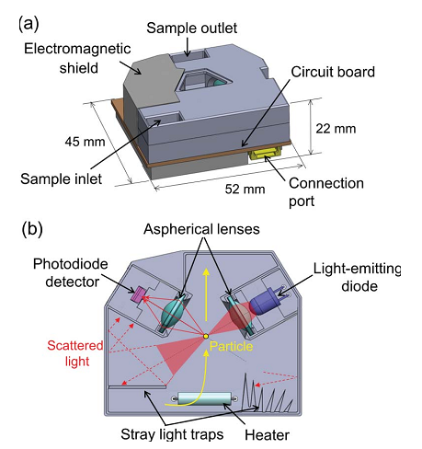
Photo 2. Panasonic’s light-scattering particle sensor
In conclusion, Panasonic’s sensor can provide data on the concentration of PM_{2.5} with certain level of accuracy in tropical areas that have high PM_{2.5} concentrations. The major findings include:
- Monthly variation of PM_{2.5} concentrations have correlation with weather fluctuation and meteorological conditions, in which the median value of the highest monthly PM_{2.5} concentration in winter is 3 times higher than the low monthly PM_{2.5} concentrations in summer.
- Daily variation of PM_{2.5} does not present high concentrations during rush hours.
- The 13 periods with daily PM_{2.5} concentrations higher than 100μg/m³ are often accompanied by a cold spill.
- Peak PM_{2.5} concentrations usually occur at night.

5. Live Learn and SPARC Lab, School of Electronics and Telecommunications (HUST): Adaptation of Low-cost Air Sensors in Regular Scientific: Activities at Schools in Hanoi
Follow up with the introduction of air monitoring system, Live&Learn brought up a summary of the organizations’ activities with a series of solution in the effort to protect the environment. In details, the presentation focused mainly on the STEM education program which is performed under the cooperation between Live&Learn and the University of Science and Technology and several schools in Hanoi. The program has been adapted from the international curriculum of Citizen Science and Village Green and focused on air monitoring. With the support from Czech Embassy and US Embassy, 70 AirSense devices have been produced by SPARC, 4 schools have been engaged (Ta Quang Buu School, Chu Van An High School, Trung Vuong High School and Hanoi Amsterdam High School), more than 50 teachers have been trained on knowledge and skills about environment topics and 50 students are provided the knowledge of environment, computer and data science. The students have the chance to practice excercise at home using AirSENse devices and then present their findings and analysis of data correlation. The workshop creates the opportunity for networking for organizations, and the Institute of Occupational Health and the Environment has proposed to collaborate with Live&Learn and HUST in providing citizens with air sensors to collect data and check whether there is any correlation between indoor air pollution and the incidence of asthma.

6. D&L: IoT Ecosystem
D&L – a technology and intergration joint stock company also brings a technological solution to the conference, as it specializes in consulting and providing solutions, services and products in the field of information technology. The company coordinates with international companies for device production and technologies transfer, and introduces PAM Air – a platform that monitors and adjusts air quality of indoor and outdoor settings to build smart house and smart city. PAM Air collects real time data (every 1- 5 minutes) from different types of sensors. The data is presented via website or mobile app: www.pamair.org (8 spots in Hanoi) to make air visual map.

III. Panel Discussion

1. Questions and Answers
Question 1: Dr. Pham Ngoc Dang – Vice Chairman of Vietnam Association for Nature and Environment Protection (VACNE): What are the location of the monitoring stations managed by Department of Natural Resources and Environment (DONRE) in Northern, Southern, and Central Vietnam?
Answer: Ms. Nguyen Nguyet Anh – Deputy Director of Centre for Environmental Monitoring, Vietnam Environment Administration: There are three air monitoring stations located in three cities across Vietnam: Hanoi, Da Nang City, and Ho Chi Minh City. Hanoi Monitoring Station is the management and executive agency, which conducts performance testing and calibration, manages and supervises equipment; while Da Nang City & Ho Chi Minh City Monitoring Stations only conducts local monitoring programs and calibration.
Question 2: Dr. Pham Ngoc Dang – Vice Chairman of Vietnam Association for Nature and Environment Protection (VACNE): What is the measuring principle of Panasonic’s air sensors? Why is PM_{2.5} concentration higher at night than during the day?
Answer: Assoc. Prof. Hoang Thu Huong – INEST: Panasonic’s air sensor is light-scattering particle sensor, which uses light to scatter small dust particles. The PM_{2.5} concentration then is calculated by converting the data into the number of particles and multiplying with particle density (the conversion coefficient is 1.4). During winter, the concentration is higher at night than during the day, depending on the sensor’s location and meteorological conditions (wind, humidity, temperature, etc.).
Question 3: Dr. Pham Ngoc Dang – Vice Chairman of Vietnam Association for Nature and Environment Protection (VACNE): What is the price of AirSense? What is the deviation of low-cost air sensors?
Answer: Dr. Han Huy Dung – School of Electronics and Telecommunications (HUST): AirSense’s price is over VND 1 million, using sensor imported from China. The data collected from AirSense will be correlated with AirVisual’s data. Regarding data accuracy, low-cost air sensor companies use correction function provided through the paton of sensor manufacturers to identify the correction function of low-cost air sensors. In calibration, low-cost air sensors provide accurate data when placed next to air monitoring stations. However, low-cost air sensors are not calibrated when moved to different locations.

2. Recommendations
- Dr. Bui Quang Son stated that the installation of air monitoring stations directly relates to two issues: investment and planning. However, the expertise of environmental researchers has not been taken into account during the installation process. In addition, the technology used for government’s air monitoring stations is standardized and acknowledged by environmental authorities worldwide, while data collected through low-cost air sensors has not accurately assess the level of pollution and still needs the government’s approval.
- Assoc. Prof. Nguyen Thi Nhat Thanh reaffirmed the importance of low cost air sensors and the need to determine the purposes of low-cost air sensors. It is also important to clarify the level of accuracy of different low-cost air sensors, and issue calibration labels. In addition, an online information disclosure system s should be established, which requires the development of a common platform using standardized data processing system to present air quality index collected from different low-cost air sensors.
- Nguyen Thi Thu Thuy – Thai Nguyen University shared that it is necessary to install monitoring stations in Thai Nguyen city to monitor local air quality and expand the market low cost air sensors to other provinces.
- Secretary General – Vietnam Respiratory Society expressed the interest to coordinate with VCAP and low-cost air sensor companies to study the correlation between air pollution and health impacts, and advocate policies on air quality management, as the association has a large cohort of patients who pay frequent visits for respiratory diseases, especially when there is a change in weather. In particular, the association can assist in collecting monthly data and connecting its partners with the network of respiratory patient in provinces to expand the market for low-cost air sensors.
- Assoc. Prof. Quang – HUST emphasizes the need for coordination in data and information sharing to improve data accuracy and calibration, as well as the importance of low-cost air sensors in indoor air quality monitoring.
Mme. Nguyen Trinh Huong – Environment Department, Ministry of Transportation states that, via VCAP, low-cost air sensor companies can be connected to share data and create a common information disclosure platform. VCAP should outline a research proposal on air quality management and low-cost air sensors development with the support from the Environment Department, Ministry of Transportation. The Environment Department has developed a roadmap to reduce the transportation emission, which will require the data from low-cost air sensors to identify the percentage of air pollution caused by traffic. D&L and the Environment Department, Ministry of Transportation, agree on the collaboration to monitor air quality index in Hanoi by placing 10-20 low-cost air sensors on public transportations.

Annex (Photos)
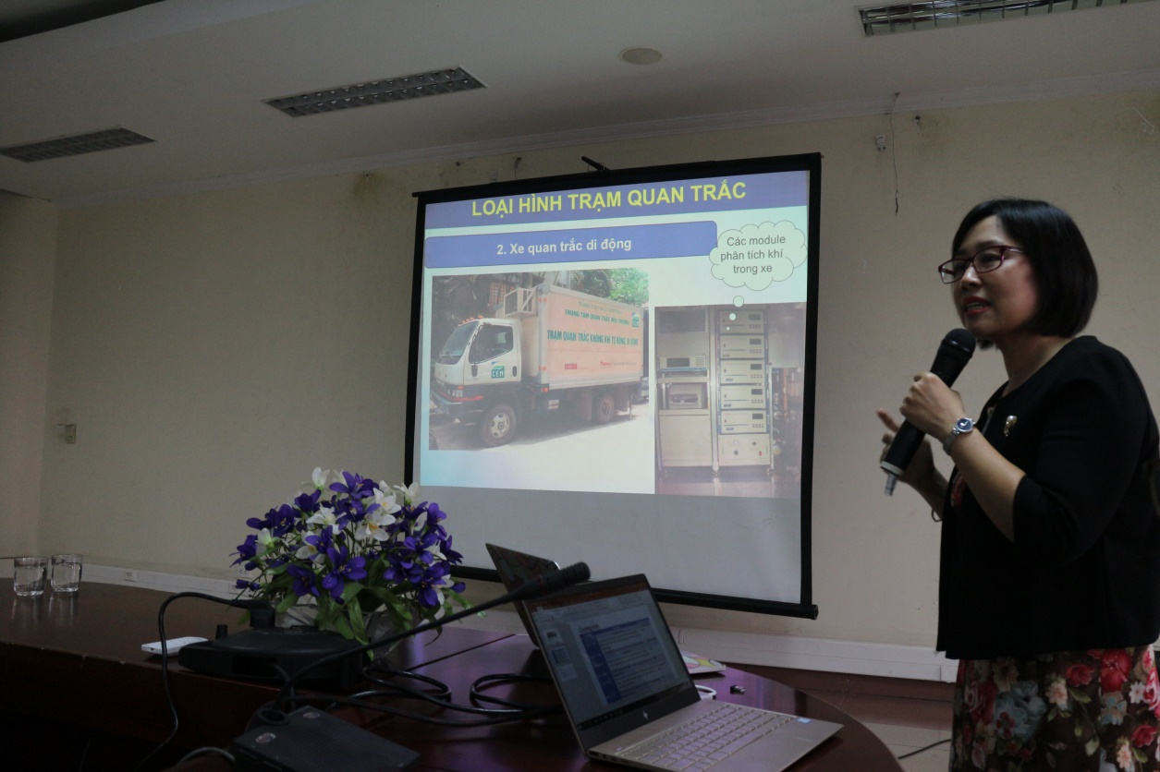
Photo 1. CEM’s Presentation
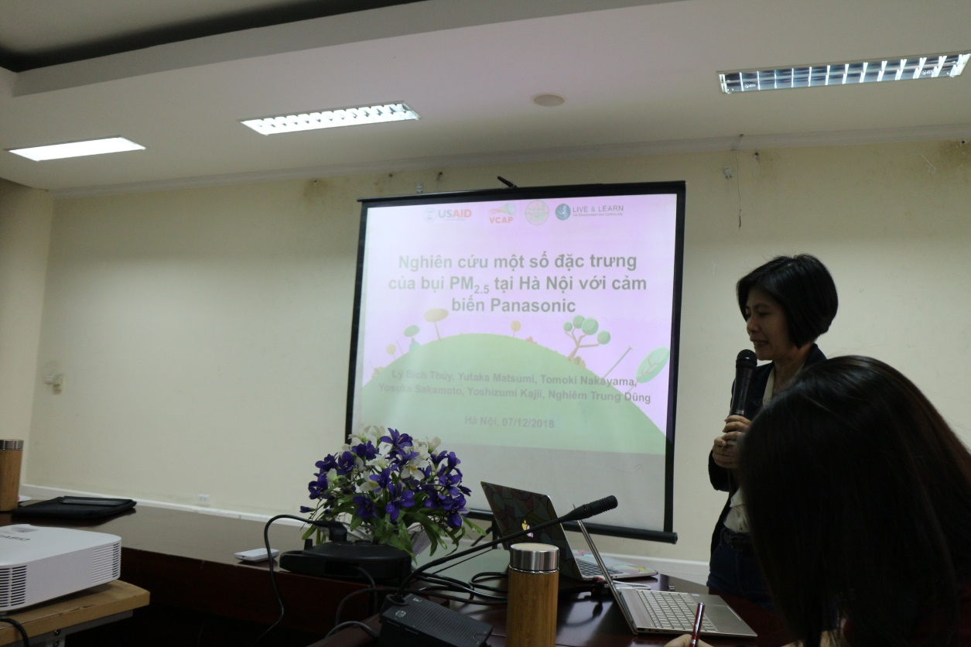
Photo 2. INEST’s Presentation
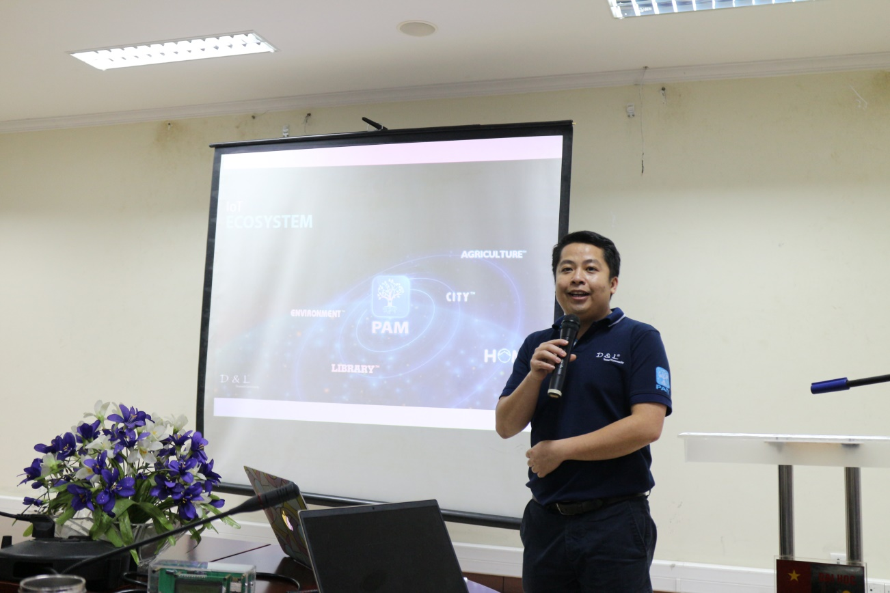
Photo 3. D&L’s Presentation
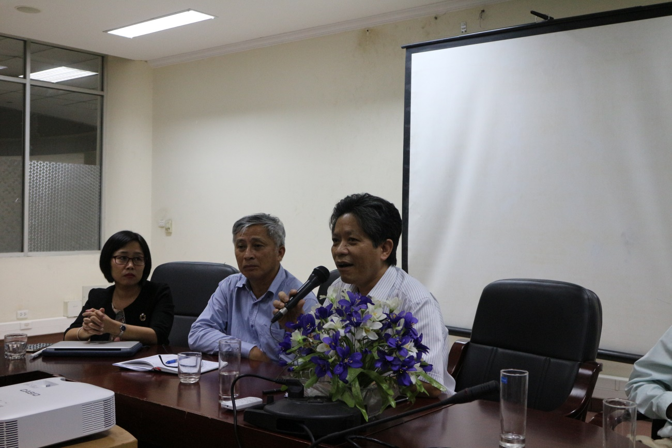
Photo 4. Panel Discussion
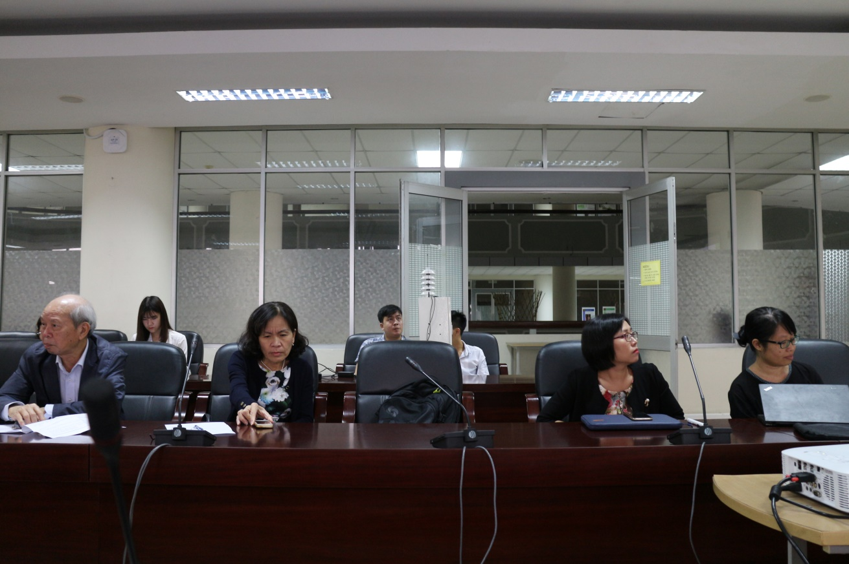
Photo 5. Panel Discussion
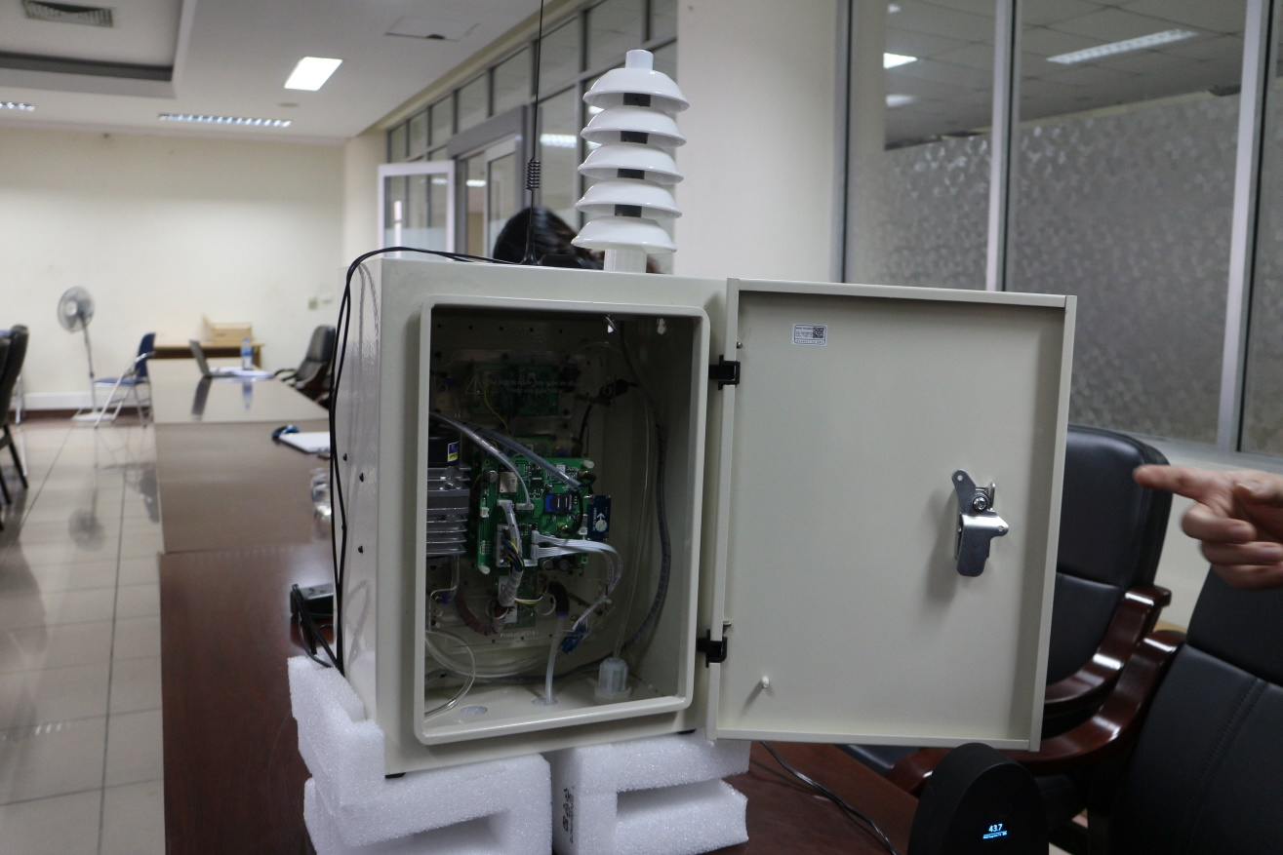
Photo 6. D&L’s Air Sensor

